This guide explains how to use the program to compute NCV data from the ephys traces. NOTE: make sure that the following steps have been completed: 1.) the folder of .txt files has been generated from the steps in STEP 1 – LAB CHART TXT FILE CONVERSION 2.) there exists an Excel file somewhere with a length corresponding to each filename (see inside the program folder for an example Excel file).

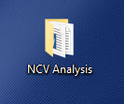STEP 1:

Locate the ‘NCV Analysis’ folder on the Desktop:

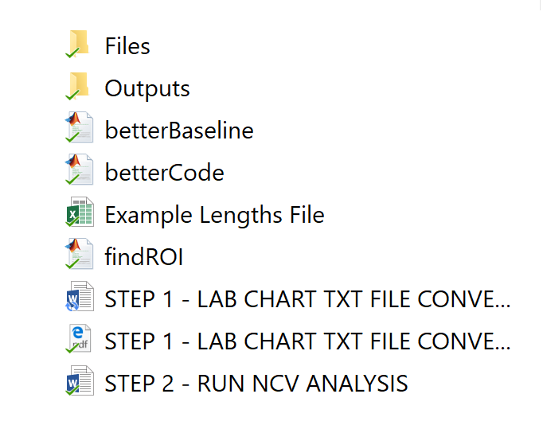This folder contains the following items:

1. The ‘Files’ folder: this is where the folder of .txt files and the lengths Excel file will go.
2. The ‘Outputs’ folder: this is where the computed NCVs for each .txt file in the input will be, along with a visualization of the data grouped by treatment.
3. Three MATLAB scripts: you will only be running the ‘betterCode’ script, don’t touch the others.
4. An example lengths file: check this to match the format. Make sure that in each txt file, the ‘.txt’ extension is removed, and each one has a corresponding length. It doesn’t matter in what order the files are however; later, if you find that you forgot one, you can just stick it on at the end.
5. These tutorials.

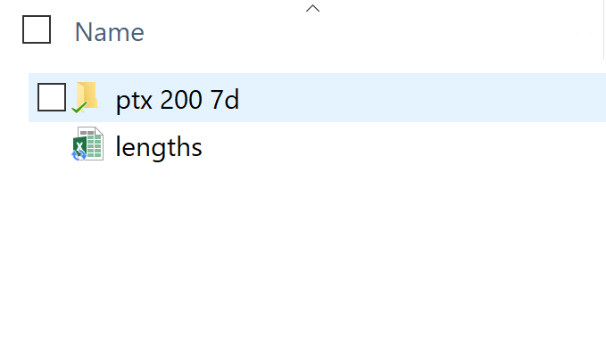STEP 2:

Open up the ‘Files’ folder and drag and drop your folder of .txt files AND the lengths file into it. NOTE: the outputs of the analysis will be named the same as the .txt file folder, so if you want to change that, change the name of the folder. Also, it doesn’t matter what you call the ‘lengths’ file.

STEP 3:

Go back to the original NCV Analysis folder and open up MATLAB by double clicking ‘betterCode’. You don’t have to worry about anything in the window except the top navigation bar:

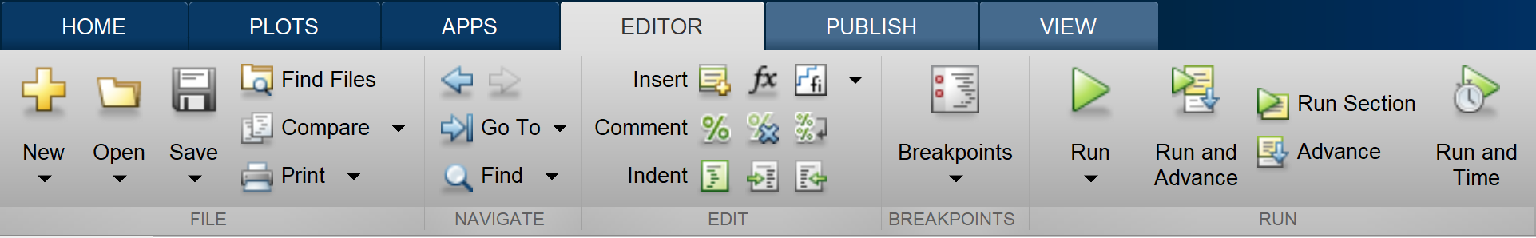

Click the green play button to RUN the program. The program should now run, and to track its progress, you can view the Command Window at the bottom. It will display something like this:

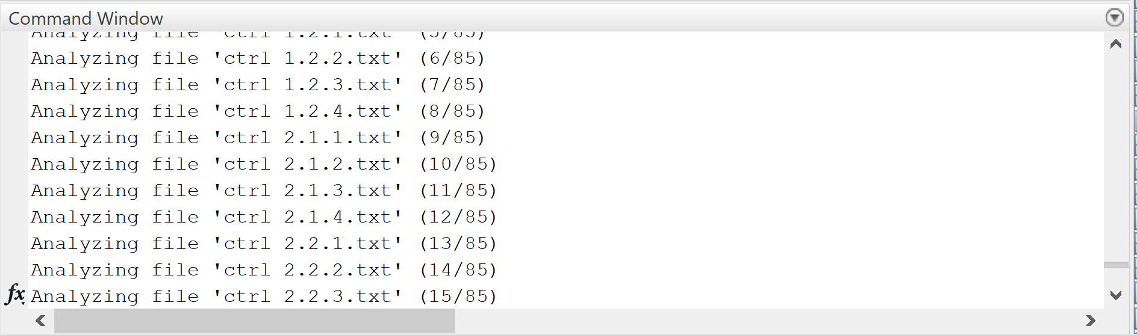

If you have forgotten to input one of the lengths, the program will tell you which .txt file doesn’t have a length and ask you how you want to proceed:

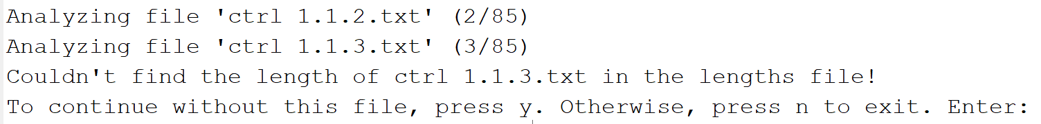

Type in an option, then press enter. Let the program run until completion, and then continue to the next step.

STEP 4:

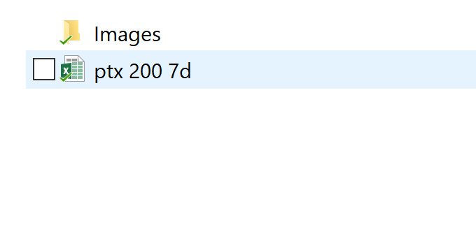It is safe to exit MATLAB, so return back to the NCV Analysis folder. Open up the ‘Outputs’ folder, and you will see two things: an excel file named the same as the original .txt file folder, and an Images folder. The excel file will contain the NCV data for each .txt file. The images folder will have some plots of the same data grouped by treatment.